# [Christopher Meloni's Delicate Dance](https://www.esquire.com/entertainment/amp34521136/christopher-melonis-delicate-dance/?__twitter_impression=true&s=09)

TV’s most beloved loose-cannon cop opens up about the lines he draws between Elliot Stabler and real life—and the ‘tricky situation’ that puts him in.

O policial mais querido da TV fala sobre as falas que traça entre Elliot Stabler e vida real – e a “situação complicada” que o coloca.

By [Gabrielle Bluestone](https://www.esquire.com/author/226842/Gabrielle-Bluestone/)

Oct 30, 2020

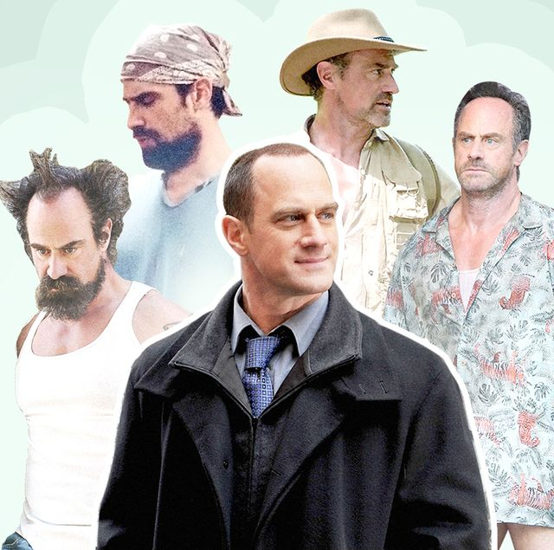

If I really want to understand the actor Christopher Meloni, Tom Fontana, an Emmy Award-winning showrunner advises me, I’m going to need to take a deep look into a prop bucket filled with real urine.

Se eu realmente quero entender o ator Christopher Meloni, Tom Fontana, um showrunner vencedor Emmy Award me aconselha, “vou precisar dar uma olhada em um baldo cheio de urina de verdade.

It’s a story that dates back to the early aughts, when Meloni was still what’s sometimes pejoratively known as a “working actor,” playing convicted murderer and sex criminal Chris Keller on the HBO prison drama, “Oz.” It was one of his first series regular roles, and, according to Fontana, the show's creator and Meloni's longtime friend, not at all the one he’d been looking to book.

É uma história que remonta aos primeiros tempos, quando Meloni era o que às vezes é pejorativamente conhecido como um “ator trabalhando,” interpretando assassino condenado e criminoso sexual Chris Keller no drama prisão na HBO, “Oz.” Foi um dos de seus personagens regulares de série, e, de acordo a Fontana, o criador do show e amigo de longa data de Meloni, nem um pouco o que ele estava procurando reservar.

“We met at a bar, and ‘Oz’ had been on, I think maybe two years by that point,” said Fontana. “And so we sat down, and Chris said, ‘Well, I don't really know why we're meeting. I don't want to do a drama show. I want to do a comedy.’”

“Nos encontramos em um bar, e ‘Oz’ começou, acho que há uns dois anos nessa época,” disse Fontana. “E então nos sentamos, e Chris disse, ‘bem, eu realmente não sei por que nós estamos encontramos. Eu não quero fazer um show drama. Eu quero fazer uma comédia.’”

“I was like, ‘Oh, well, I don't know, I can't tell you that ‘Oz’ is very funny, but let's just stay in touch,’” Fontana said. They did, and when Fontana reached out again with his idea for a charming sociopath who enters into a violent love affair with a fellow inmate, Meloni “embraced it immediately.”

“Eu estava como, ‘Oh, bem, eu não sei. Eu não posso lhe dizer isso ‘Oz’ é muito divertido, mas vamos apenas nos manter em contato.’” Fontana disse. Eles fizeram, e quando Fontana estendeu a mão novamente com sua ideia para um charmoso sociopata que entra em um caso de amor violento com um colega presidiário, Meloni abraçou imediatamente.”

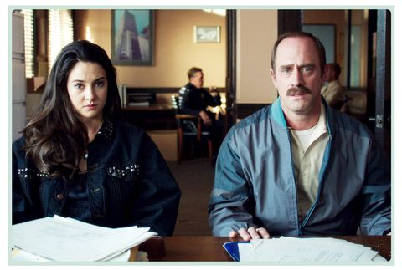

Meloni in

“He's a courageous actor and he's really in touch with all the parts of himself. And I say that with great affection, in the sense of that he knows the darkness in his soul as well as the light,” Fontana said. “What he brought was this rare combination of sexy, dangerous, and vulnerable, and he was able to tap into any of those at any moment depending on what the scene called for.”

“Ele é um ator corajoso e ele está realmente em contato com todas as partes de si mesmo. E eu disse

Still, when Fontana conceived of a 15-second scene where a fully nude Keller openly pissed into a bucket, he figured that the crew would rig together a tube rather than ask Meloni to tap into his bladder on top of everything else. But Meloni, he soon learned, had other ideas.

“On the day that we were going to shoot it, the crew was explaining to him how they would attach the tube, and what angle the thing would be shot at, so that you couldn’t see the tube, so that it looked like he was urinating,” Fontana said. “And Chris said, ‘Oh no, no, no, I don't want any of that. I'll urinate when the time comes.’ So I'm on the set and I say to him, ‘Are you sure you want to do this, Chris?’ And he said, ‘Yeah, yeah, yeah, absolutely. Absolutely. I want it to look as real as possible.’”

ADVERTISEMENT - CONTINUE READING BELOW

"He knows the darkness in his soul as well as the light."

Meloni chugged a few bottles of water, but just as he began to, uh, method act, a technical flaw in the shot forced them to cut the scene mid-stream.

“They fix whatever the problem was, and the director says, ‘Okay, action,’” Fontana said. “And Chris peed again, and the take was a good take, and the director yelled, ‘Cut.’ And he said, ‘Hey, Chris, that's it. That's the take.’”

“Chris turned to us,” Fontana said, “And said, ‘Are you sure? I've got another one in me.’”

At the time, Meloni wasn’t just playing a violent rapist on HBO’s breakout prison show — he was also regularly “Jekyll and Hyde-ing himself,” as Fontana put it, by playing a dedicated detective on NBC’s breakout sexually-based offenses police procedural, “Law & Order: SVU.” Not only were the roles diametrically and tonally opposite, their shoots also often occurred on the same day.

“[It was] insane….You're just doing these odd switches and hoping you're doing justice to it, so there's a lot of anxiety. But a lot of it's so thrilling, because I was very much aware that, at least from my point of view, I was the luckiest actor walking the earth in that moment,” Meloni said on a recent Zoom call from his lake house in Connecticut, where he holed up with his family for much of the summer.

He used much of that time to waterski and work out, both of which he finds almost meditative. (He used to fly planes too, a hobby he picked up after John Travolta took him out for a whirl, but quit in 2018 after losing an engine mid-air. The really frightening part, he said, was the bill he got afterward.) These days, he goes out on his speedboat early in the morning while the water is still glassy. “Water skiing to me, is kind of this practice of Zen, which is in the midst of this great speed, you're constantly trying to find speed across the wake, so you can get around the buoy and into position to pull yourself back across the other side of the wake,” Meloni said. “In the midst of all that, you have to practice, practice, practice so that your form is great, and you need to relax. You need to understand what you're doing. So it's this thing of being Zen in the middle of this frenzy, and it's a good thing for me to practice.”

ADVERTISEMENT - CONTINUE READING BELOW

Patience, “Zen”, and calm have been useful to him this year. Nearly a decade after “Law & Order” contract negotiations broke down in 2011, prompting Meloni to walk away after a whopping 12 seasons and 272 episodes, NBC announced, in early spring of this year, that Meloni would reprise the role of Detective Elliot Stabler with his own primetime spinoff focused on organized crime.

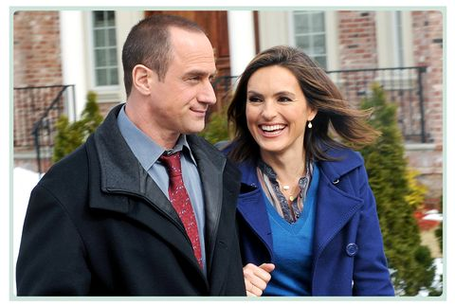

The new show will see him back on screen with his former co-star Mariska Hargitay, who plays his old partner, Detective Olivia Benson, a blessed reunion.

The announced fall release has, like most every show, since been pushed to 2021 due to the pandemic.

So Meloni’s been doing a lot of hurrying up and waiting for this new-old chapter to start, promoting in the meantime a new Hulu streaming series, “Maxxx,” practicing his guitar and doing woodworking projects with his kids.

“I don't know what the feeling is. It feels like I'm gearing up for a football game that's two months away, so it's driving me a little crazy with anticipation, and a million and one emotions,” Meloni said.

The new show will also see him back on screen with his former co-star Mariska Hargitay, who plays his old partner, Detective Olivia Benson, a blessed reunion that a large number of dedicated Instagram accounts and fan fiction writers have been eagerly anticipating for the last decade. This summer, Meloni and Hargitay further set the vast “Bensler” fandom aflame with [a lakeside selfie](https://www.instagram.com/p/CC2UcUdgAgI/) that quickly went viral. (Hargitay, who is close with the Meloni family, is also godmother to Meloni’s eldest kid, 19-year-old Sophia.)